**1.INTRODUCTION: *****OVERVIEW:** *The Project is about "Smart Security For Home Using IoT".It comes under the category of "Internet Of Things".The main Objective of this project is to setup "Emergency-Alert-System",which is under the control of Voice****.*  *****PURPOSE:** *The Above Project is used to alert the community or people ,when there is an emergency and take immediate action.It also includes the feature of camera capturing ,which further helps in investigating the crime scenes .It decreases the work of police and cbi.It ensures more safety as it uses a buzzer system along with fastsms,which alerts nearby people immediately and efficiently.* **2.LITERATURE-SURVEY: *****EXISTING-PROBLEM:** *Ensuring more safety and security by prototyping a "Emergency-Alert-System".* **\*\*\*\*\*PROPOSED-SOLUTION:** *It is built using Python,IOT Application Development,IOT Cloud Platform ,IOT CommunicationProtocols.*  **3.THEORITICAL-ANALYSIS: *****BLOCK-DIAGRAM:** *These are the following steps involved in IOT App Developing.*

APPLICATION

CLOUD

COMMUNICATION

DEVICE

**\*\*\*\*\*HARDWARE/SOFTWARE DESIGNING : ----->***Python (for code snippet)*  **----->***IOT Application Development (for interface )*  **----->***NODE-RED Application development* **----->***MIT App development* **4.EXPERIMENTAL-INVESTIGATIONS:***Investigations are performed on "Emergency-Alert-System" and performance is satisfied.* **5.FLOWCHART:**

MIT APP

Nodes Creation to display UI

CODE SNIPPET CREATION

ACCOUNTCREATION

**6.RESULT: ----->***Creating accounts in IBM Cloud,FastSMS and MIT (if required).* **----->***Creating a Local Audio file ,which contains "help help"* 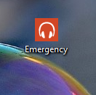**----->***Creating a code snippet to capture the images* 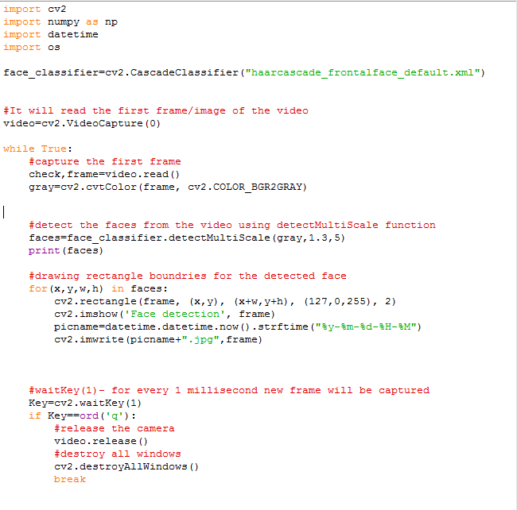**----->***Creating a code snippet for speech to text service to read the local audio file* 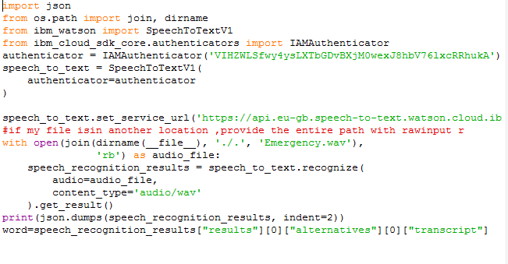**----->***Creating a code snippet for producing the buzzer sound* 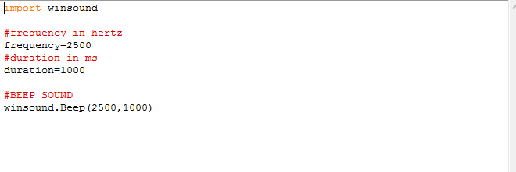**----->***Creating a code snippet for sending a SMS ,indicating the Emergency* 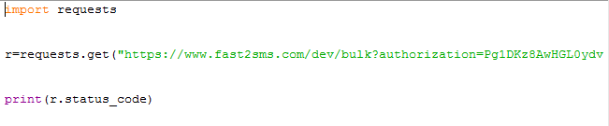**----->***Creating code snippet for integrating buzzer sound,c*a*mera capturing and sending a sms to people around the crime situation* 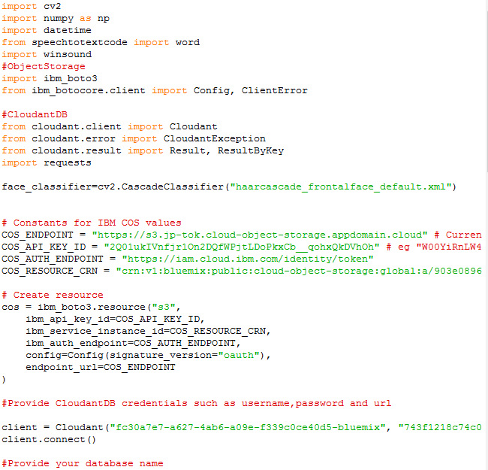

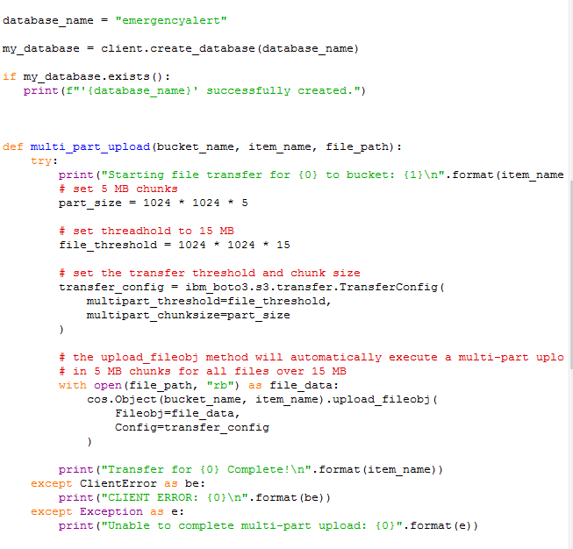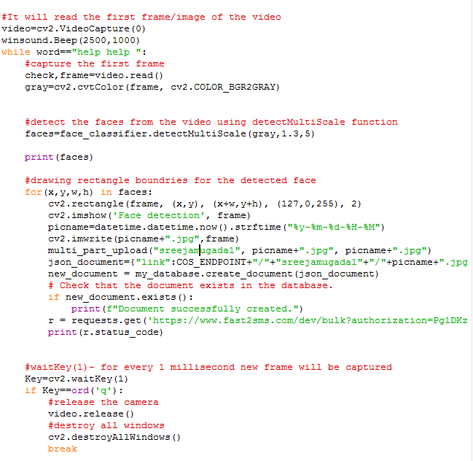**----->***ScreenShot showing Database "emergencyalert " created in IBMCloudant* 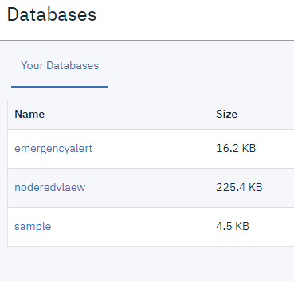**----->***Screenshot showing buckets stored in obj storage.* 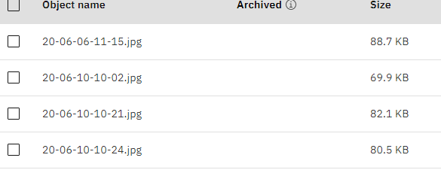**----->***Creating node-red application* **----->***ScreenShot displaying UI App* 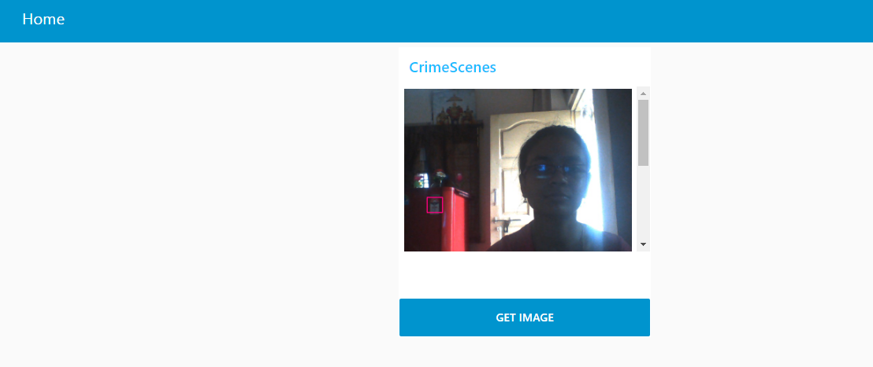**----->***Screenshot of MIT BLOCKS* 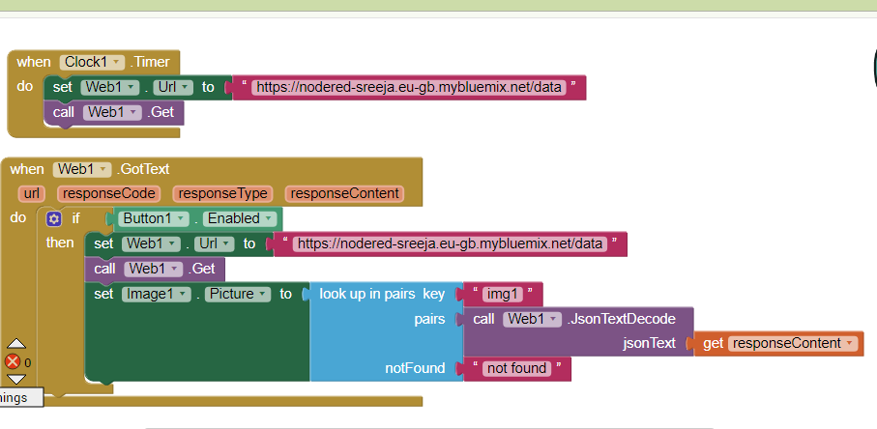

**----->***Screenshot of the MIT App* 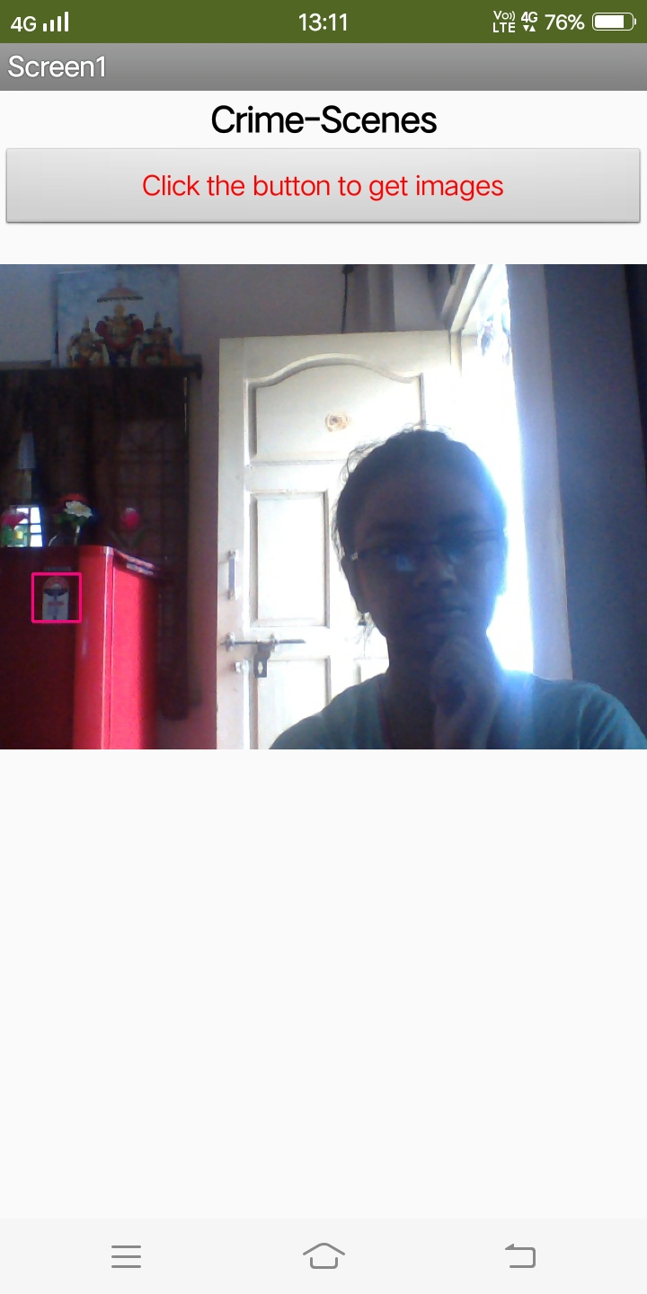**----->***"***Emergency-Alert-System***" is Created using Node-red UI And MIT App* **7.ADVANTAGES &DISADVANTAGES: *****ADVANTAGES: ----->***High Reliability*  **----->***Safety Enhancement* **----->***Cost Reduction* **----->***Improved Customer Engagement*  **\*\*\*\*\*DISADVANTAGES: ----->***Sometimes Slow due to Internet Connectivity* **8.APPLICATIONS: ----->***Used in Restricted**Areas* **----->***Used in communities,colonies..* **----->***Used in Institutions,Army areas*

**9.CONCLUSION: ----->***This system**can overcome the problems of lack of Automated System for captiring Crime scenes.*  **----->***Consequently,the time required for investigation is reduced and improves the efficient help for people.*

**----->***This project provides a feasible solution to alert the people and reduces loss of lives.*

**10.FUTURE_SCOPE: ----->***It can be used in places where "Crimes" are more or increasing day by day.* **----->***It can be used for weather and AMBER alerts in future*

**----->***It can be used in Accident Prone Areas.*

**----->***It can be used as camera capturing Attendance.*

**11***.***BIBILOGRAPHY:** *GITHUB ACCOUNT(UPLOADED-CODES)*

**\*\*\*\*\*APPENDIX:** **#Note:copy and pasting is not allowed in my zoho.so,i have made screenshots. ----->speech-to-text service is imported in this code,to make code more reliable.**